SECTION M

TURBOCHARGER

CONTENTS

|  |  |
| --- | --- |
|  | Chapter |
| General Information .. | 1 |
| Construction Details .. | 2 |
| Cooling System | 3 |
| Lubrication System .. | 4 |
| Service Operation | 5 |
| Maintenance .. | 6 |
| Turbocharger Dismantling .. | 7 |
| Cleaning and Inspection | 8 |
| Clearances | 9 |
| Turbocharger Assembly | 10 |
| Special Tools .. | 11 |

CHAPTER 1

GENERAL DESCRIPTION

1. The turbocharger is a self-contained unit, composed of a gas turbine and a centrifugal blower, mounted on a common shaft with the necessary surrounding casings. The exhaust gas from the engine is conveyed through a manifold system to the turbine, which utilises some of the energy in the exhaust gas, otherwise wasted. This energy is used to drive the blower, which furnishes all the air required by the engine, at a pressure above atmospheric, through a conventional air intake manifold.
2. The compressed air delivered by the turbocharger accomplishes two ends; first, it scavenges the hot residual gases otherwise left in the cylinder at the end of the exhaust stroke, and replaces these with cooler fresh air; second, it fills the cylinder with an air charge of higher density at the end of the induction stroke. The provision of a greater amount of fresh air permits the combustion of a correspondingly greater amount of fuel and consequently a higher output from a turbocharged engine.
3. The valve timing of an engine arranged for pressure charging differs primarily from that of the same engine normally aspirated in that the exhaust valves of the pressure charged engine close later, and the inlet valves open earlier. The valve overlap, or period when both valves are open simultaneously, is considerably greater, permitting effective scavenging of the cylinders.
4. Scavenging the combustion space with cool air effects a considerable degree of cooling of the cylinder head, cylinder walls, valves, and piston. For this reason, a greater amount of fuel can be burned and greater power developed by a turbocharged engine without harmful effects on these engine parts due to excessive heat.
5. No control over the turbocharger is necessary, as the correlated action of the turbine and blower is entirely automatic. The speed and output of the turbocharger vary automatically and practically instantaneously with variations in engine load and/or speed.

CHAPTER 2

CONSTRUCTION DETAILS

1. The turbocharger basically consists of a rotor assembly carried in an intermediate casing to which are secured the turbine casing assembly and the blower casing assembly.
2. The engine exhaust gases are ducted to the turbocharger by the engine exhaust manifolds, an exhaust bend and a gas inlet casing (Section LC).
3. All item references are for Fig M.7.

CASINGS

Turbine Casing Assembly

1. The assembly consists of turbine casing (2), turbine inlet casing (1) and nozzle ring (39). The nozzle ring is secured to inlet casing (1) by setbolts (33) and locknuts (35), whilst the inlet casing is secured to the turbine casing (2) by capscrews (32).
2. The nozzle ring which is precision cast from special heat resisting alloy has integral blades to direct the exhaust gases on to the turbine blades at the correct angle.
3. The cast turbine casing (2) is cored to provide cooling water passages. A flat rectangular flange is machined on the top face of the casting for the exhaust outlet connection, whilst the underside is machined to accept a mounting foot. Pads are provided on the sides for support bracket mountings.

Intermediate Casing

1. Cast intermediate casing (10) carries the rotor assembly and forms the division between the exhaust and air side of the turbocharger. It is cored to provide cooling water passages and is drilled for a lubricating oil supply to the rotor bearings. The casing is secured to the turbine casing by capscrews (6) and to the blower casing by studs (9) and nuts (7).

Blower Casing Assembly

1. This assembly consists of blower casing (13) and inlet casing (16), secured together by setscrews (26). Vaned diffuser (27) is attached to the inlet casing (16) by countersunk head screws (12) locked by peening and when assembled is clamped between the inlet and intermediate casings.
2. Air enters the inlet casing axially and is discharged radially from the impeller through the vaned diffuser into the blower casing from where it is discharged tangentially.

ROTATING ASSEMBLY

1. The rotating assembly consists of the following components: turbine disc (3), shaft (5), thrust collar (15), impeller/inducer assembly (20), nose piece (23), stud (24) elastic stop nut (22) and key (21). The turbine disc is spigot fitted to the shaft with a light press fit to ensure concentricity whilst positive torque transmission is assured by dowel pins (36). Thrust collar (15) which seats against a shoulder on the shaft provides the axial location for the impeller/inducer assembly, the drive from the shaft being via key (21) and impeller insert (19). The entire assembly is held together by stud (24), nose piece (23) and elastic stop nut (22).

Impeller/Inducer Assembly

1. The assembly consists of a radial bladed impeller (17) which is completely machined from a forging and a precision cast inducer (18) to provide guidance for the inlet air. The impeller and inducer are shrunk together and the bore is fitted with a steel insert (19) serving to limit the bore expansion during operation thus maintaining proper running balance.
2. The impeller/inducer sub-assembly is dynamically balanced and overspeed spin tested and the turbine disc/shaft sub-assembly statically balanced before assembly into a complete rotor assembly, after which the complete rotor is dynamically balanced. Either one of the components of the assembly can be replaced if required, but only by the manufacturer or an accredited agent with suitable balancing equipment.

BEARINGS AND OIL SEALS

1. The bearings (4) and (11) are of the 3-lobe sleeve type, and are FROZEN into the intermediate casing. Rotation of the bearings in their housing is prevented by pins (30) and (31). The turbine end bearing flange is provided with a grooved thrust face and carries the axial thrust load of the rotor. Endfloat is limited by the clearance between the thrust collar (15) and the flange of the blower end bearing (11).
2. Oil leakage into the turbine casing and blower casing is prevented by the oil seals (37) and (14). A snap ring (38) retains the turbine end oil seal in place whilst the blower end oil seal is held by countersunk machine screws (25) locked by peening.
3. Air at impeller discharge pressure is used to pressurise the blower end oil seal (14). The turbine end oil seal (37) is pressurised by high pressure air from the blower casing.

CHAPTER 3

COOLING SYSTEM

1. The turbocharger cooling system is supplied with coolant from the engine cooling system via a port in the exhaust manifold and turbocharger foot, the coolant entering at the bottom of the turbine casing. The ports are sealed by 'O' rings (Section LC).
2. After entry into the turbocharger, the coolant flow is split to supply both the turbine casing and the intermediate casing, the holes in the casings functioning as metering elements to proportion the flow correctly. The two flows rejoin at the top of the casings before discharge from the turbine casing to the gas inlet casing (Section KA and Section LC).

CHAPTER 4

LUBRICATION SYSTEM

Lubricating oil for the turbocharger bearings is supplied from the engine lubricating oil system, the flow rate and pressure being controlled by an orifice plate. An independent oil filter is not fitted as the main lubricating oil filter, filters to 8 micron size.

Lubricating oil is piped from the engine free-end cover gallery to the connection on the turbocharger intermediate casing and then via a screwed in stainless steel tube (41) to a drilled gallery (40) supplying the bearings. Drain oil from the bearings drops to the bottom of the intermediate casing from where it is returned to the engine via a drain adaptor to the turbocharger foot and is then piped back to the engine camtrough. An additional drain, screwed directly into the intermediate casing is also fitted, the piping merging with that from the turbocharger foot.

CHAPTER 5

SERVICE OPERATION

Initial Start

1. Before attempting to run a newly installed turbocharger:-
2. Check that the holding down bolts and nuts are tight. Check air delivery clamp band(s) for security.
3. Check that lubricating oil is available at the turbocharger oil inlet (Section DA).
4. Check that engine cooling system has been filled. The cooling system is self venting.
5. Start engine, run up to idling speed and immediately shutdown. Listen to turbocharger run down; it should be smooth and non-jerky.
6. Start and run the engine. After a few minutes, feel the turbine casing and coolant pipes to ensure that the temperature rise is gradual and evenly distributed.
7. At the first opportunity run the engine under varying load conditions, and record the following to serve as a basis for future checks on turbocharger and engine performance:
8. Turbocharger speed
9. Air delivery pressure
10. Exhaust temperatures after the cylinders
11. Exhaust temperatures after the turbocharger

Routine Starting and Running

1. Other than ensuring that any maintenance work required has been completed, no further attention is required, turbocharger functioning being entirely automatic.
2. It is recommended that a daily record is kept of the air delivery pressure and exhaust gas temperatures to help detect any deterioration in performance.

Stopping

1. Before stopping the engine, the turbocharger speed should be allowed to attain a steady state with the engine idling.

Emergency Operation

1. Should an accident or failure of some part of the turbocharger prevent or render operation of the unit inadvisable, the engine can be operated in a normally aspirated mode until repairs can be made.
2. Cooling water circulation must be continued and under no circumstances must the pre-turbine exhaust gas temperature exceed the maximum stamped on the turbocharger name plate. THE ENGINE SPEED AND LOAD APPLIED MUST BE REDUCED TO MEET THESE REQUIREMENTS.

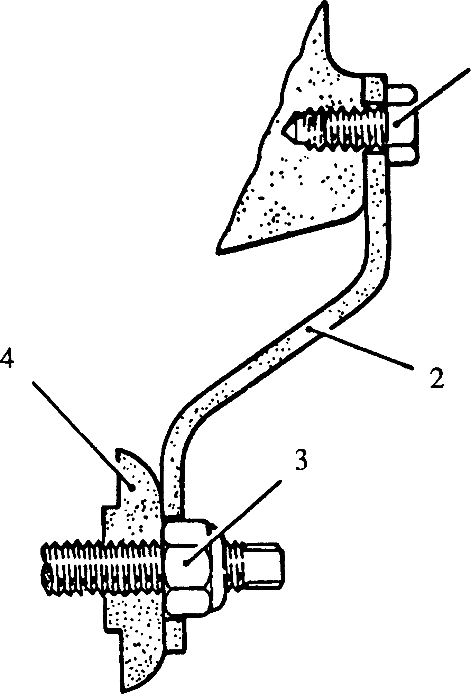

Key To Numbers

1. Setscrew, blocker to inlet casing 3. Rotor elastic stop nut
2. Rotor blocker 4. Nose piece

Fig M.l Rotor blocker fitted

1. If possible, the turbocharger rotor, blower casing and intermediate casing should be removed together with the ducting from the air filter and the open end of the turbine casing closed with a steel plate and suitable jointing.
2. If it is not feasible to remove the turbocharger rotor, it should be prevented from turning by fitting the rotor blocker (2)(Fig M.l), after removal of the air intake casing from the air filters.
3. If the engine has been operated under the above conditions, the turbocharger should be completely dismantled and inspected as described in Chapters 7 to 10 before returning to normal operation.

Unsatisfactory Performance

1. Deterioration in engine efficiency will be reflected in the performance of the turbocharger. For example, defective combustion due to faulty fuel injection, burnt valves, worn or broken piston rings or worn cylinder liners may cause heavy carbon deposits to build up in the internal passages of the turbocharger, which will eventually result in unsatisfactory operation.
2. If a comparison of past and present routine pressure and temperature readings indicates that the performance of the turbocharger is deteriorating, the cause may be one or more of the defects listed in the following table.

|  |  |  |
| --- | --- | --- |
| DEFECT | POSSIBLE CAUSE | REMARKS |
| Low air delivery pressure | Defective air inlet flow  Dirty air filter as indicated by the inlet depression | Clean air filter |
|  | Compressor/inducer assembly dirty | Wash compressor or remove inlet casing and clean |
|  | Leaking joints in air supply piping or manifolds | Rectify leaks |
|  | Defective exhaust gas flow  Exhaust ducting obstructed between turbine casing and atmosphere | Strip, check and clean |
|  | Exhaust silencer (if fitted) needs cleaning or repair  Carbon blockage in engine ports | Clean, repair and renew  Decarbonise |
|  | Incomplete combustion resulting in excessive carbon formation in turbine and/or nozzle ring | Service engine and turbocharger |
|  | Mechanical Defect  Low rotor speed, due to some mechanical hindrance | Check movement of rotor by hand  If necessary, strip and check |
| High air delivery pressure | Defective Combustion  Incomplete combustion, resulting in excessive carbon formation on the nozzle ring, causing an increase in turbine speed | Service engine and strip and overhaul turbo­charger |
|  | Prolonged combustion due to faulty fuel injection | Service engine |

Reporting Defects

1. To ensure the maximum co-operation between manufacturer and user, all initial correspondence regarding turbochargers should preferably be addressed to the engine manufacturer and to minimise the time in dealing with the service or breakdown, the following information should be supplied.
2. Turbocharger type and serial number.
3. Engine type and number.
4. Running time of the turbocharger and running time since last overhaul.
5. Date installed and date entered service.
6. Approximate maximum speed at which the turbocharger has operated.
7. Maximum turbine inlet temperature.
8. A full report on the defect, giving circumstances of the failure including details and list of any damage to the turbocharger components.
9. If the lubrication or bearing systems are involved, state the type of oil used and details of any changes for the relevant period prior to breakdown.

If the coolant system is involved, give details of the system, pressures and temperatures and the type of water treatment employed (include a sample of the coolant).

CHAPTER 6

MAINTENANCE

Maintenance Periods

1. Refer to Engine Maintenance Schedule, Section EA.

Compressor Washing

1. Whilst this cleaning procedure is a useful method of maintaining optimum impeller condition in between routine overhauls by ensuring cleanliness of the impeller vanes and diffuser blades, it is an adjunct to, not a substitute for periodic overhaul of the turbocharger.
2. REGULAR WASHING IS ESSENTIAL. Under no circumstances should the impeller be left until heavily coated; this will result in incomplete deposit removal with resultant out-of-balance of the rotor assembly.
3. Optimum results may be obtained with a variety of cleaning fluids and the choice will depend to some extent on the nature of the contaminents in the air supply to the turbocharger. The recommended fluid is a water, kerosene, emulsifier mixture in the following proportions:-

48% water

48% kerosene

4% emulsifier (Nedol or equivalent)

Nedol is obtainable from

Shell Chemicals U.S.A. Ltd.,

Industrial Chemicals Division.

1. The recommended quantities per turbocharger and the approximate duration of injection are as follows:-

|  |  |  |  |  |  |
| --- | --- | --- | --- | --- | --- |
| Quantities in cubic centimetres | | | | Total  approx. | Minimum Period of injection |
| Water | Paraffin | Emulsifier | Total |
| 140 | 140 | 12 | 292 | 0.292 litres (0.5 pts) | 15 seconds |

Procedure

1. To ensure that the turbocharger speed and air inlet manifold pressure are high enough for efficient cleaning, the engine must be operated in excess of 50% full load.
2. Prepare sufficient mixture for turbocharger cleaning.
3. Start engine and operate until normal running temperatures are attained.

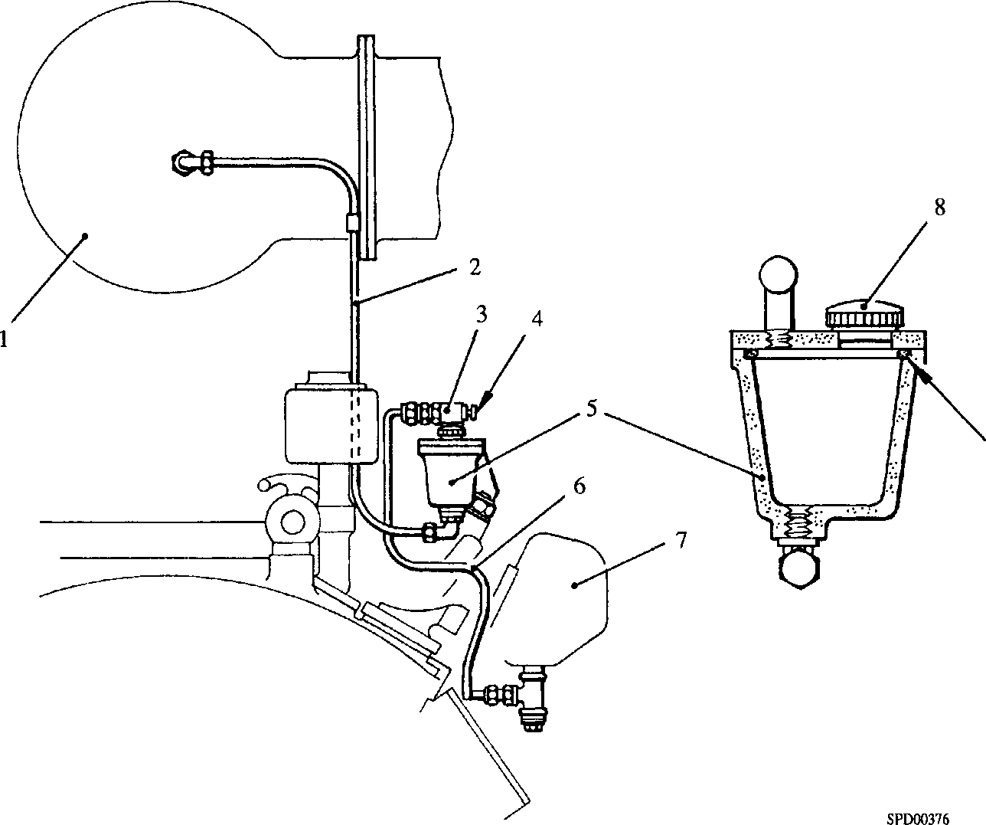Fig M.2 Impeller water washing

**Key To Numbers**

1. Turbocharger
2. Supply pipe
3. Valve
4. Operating button
5. Reservoir
6. Air pipe
7. Air manifold
8. Reservoir cap
9. Reservoir seal
10. Remove filler cap (8)(Fig M.2), fill reservoir with cleaning fluid and replace cap. Check that the cap is securely tightened to form an airtight seal.

NOTE Failure of cap seal or reservoir seal (9) will result in slow or non operation of the procedure.

1. Raise engine speed to normal and increase load to between 50% and 75% of full load. In the case of variable speed installations, eg. marine propulsion engines, increase speed to a minimum of 1200 revs/min to ensure that the load is in excess of 50%.
2. When speed and load are steady, depress button (4) and hold for a period of 15 seconds. This will admit air from engine manifold (7) to the reservoir via pipe (6) and valve (3) pressurising it and discharging the cleaning fluid to the turbocharger via pipe (2).
3. One filling of the reservoir is sufficient to clean a turbocharger under normal conditions. Should it appear that cleaning is incomplete, it is permissible to repeat the procedure immediately.
4. Following the injection process it is necessary to dry the charge air system, if it is suspected that condensate cleaning fluid is trapped in the system, stop the engine after a few minutes and allow the fluid to drain via the condensate drain valves in the air manifolds (Section LC). The drain valves are automatic in operation and close during engine operation.

Compressor and Diffuser Cleaning

1. Remove air trunking between air filters and turbocharger air intake casing (Section LA).
2. Disconnect governor mechanical and electrical inputs. Disconnect fuel injection pump control linkage at the governor lever. Disconnect boost piping to governor. Release securing setscrews and remove governor.
3. Remove setscrews (26)(Fig M.7) securing inlet casing (16) to blower casing (13). Using these setscrews as jacking screws in the tapped holes, break the joint between the two casings and using suitable lifting equipment withdraw the inlet casing complete with diffuser (27). DO NOT ATTEMPT to remove the diffuser from the inlet casing.

NOTE To avoid damage to the impeller/inducer assembly the lifting equipment should not allow any appreciable vertical movement.

1. The impeller, diffuser and blower casing may now be cleaned using Bendix cleaner. DO NOT use a caustic solution, wire brush or scraper on these parts.
2. After cleaning, the inlet casing should be refitted using flexible gasket 16113 on the mating face to the blower casing. Torque load the setscrews to 30 to 40 lbf.ft.

Protection Against Corrosion

1. Installed turbochargers are connected to the engine coolant and lubricating oil systems and are automatically inhibited against corrosion via the engine procedures (Section Y).
2. Overhauled turbochargers which are held as spares must be prepared for long-term storage. Instructions for carrying out such work may be obtained from Elliot Turbochargers.
3. New turbochargers leaving the factory are inhibited with Tectyl 502. Inhibiting should be repeated at four monthly intervals.
4. In addition to inhibiting, the following precautions are taken to prevent damage to turbochargers during transit and short term storage.
5. Each unit is finished with high quality paint and external steel and bright parts are treated with acid-free mineral grease. Hardboard blanks are fitted to all machined facings, outlets, etc.
6. Spare parts and tools are treated similarly with preservative and grease resistant packing where necessary. Rubber joints and sleeves are chalk dusted and wrapped in grease resistant paper, while other forms of jointing material are suitably dry packed.

LIMITED RIGHTS LEGEND

M

**use, duplication or disclosure of this information which is the property**

OF GEC ALSTHOM DIESELS LIMITED BY THE U.S. GOVERNMENT OR BOLLINGER IS SUBJECT TO THE RESTRICTIONS SET FORTH IN DOD FAR SUPP 252.227-7013 (a) 15.

1. When necessary, the unit is bolted to a wooden base and formers which prevent movement inside the packing case. For overseas shipment the case is lined with waterproof material.

CHAPTER 7

TURBOCHARGER DISMANTLING

General

1. Complete overhaul, including detailed inspection, crack detection and pressure testing can be undertaken by Elliott Turbochargers, if required. In addition Elliott offer the facilities of their technical organisation and the services of skilled engineers for the investigation of any matter connected with turbochargers.
2. A turbocharger removed for transportation for overhaul must be protected as described under Protection Against Corrosion (Chapter 6).

NOTE All item references are for Fig M.7 unless otherwise stated. **Dismantling**

1. Remove turbocharger from engine (Section LC).
2. 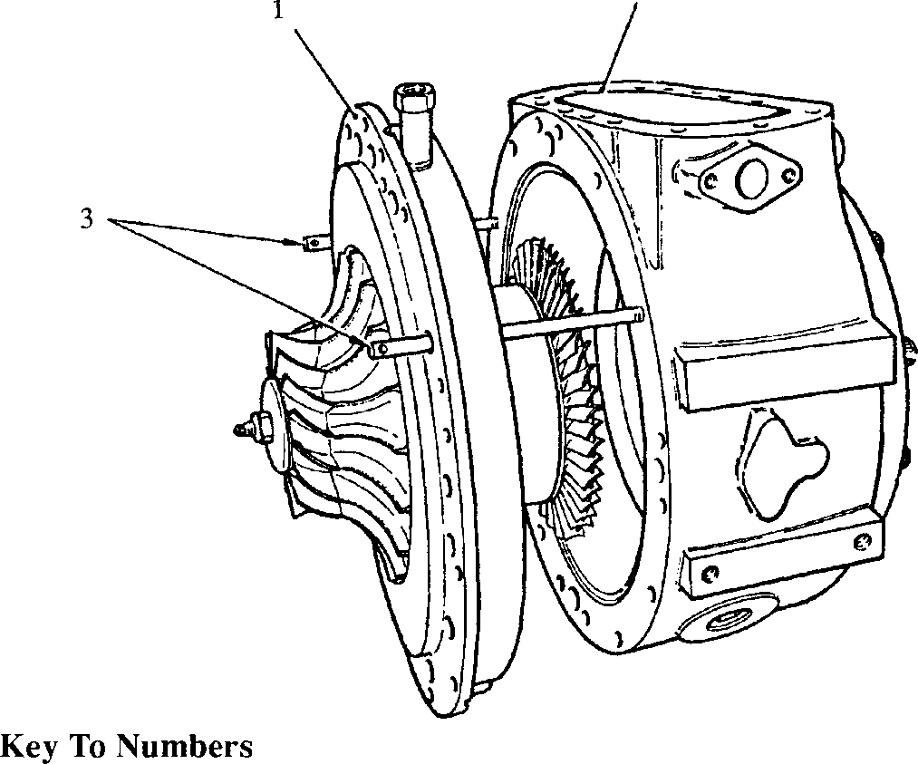If the turbocharger has been removed as a unit, remove the exhaust bend and gas inlet casing (Section LC).

**SPD00375**

1. Guide pins
2. Intermediate casing
3. Turbine casing

Fig M.3 Withdrawal of intermediate casing

Casings

NOTE To avoid damage to the impeller/inducer assembly when removing the blower inlet casing and the blower casing, the lifting equipment should not allow any appreciable vertical movement.

1. Remove setscrews (26) and lockwashers, attach lifting equipment and, using the setscrews as jacking screws in the tapped holes, break the joint and remove the blower inlet casing (16).
2. Remove nuts (7) and lockwashers, attach lifting equipment and using setscrews (26) as jacking screws in the tapped holes, break the joint and remove the blower casing (13).
3. Remove two capscrews (6) and fit intermediate casing guide pins (3)(Fig M.3). Remove remaining capscrews (6). Fit special jacking screws, and break the joint between the intermediate and turbine casings. Remove the jacking screws. Carefully slide the intermediate casing/rotor assembly clear of the nozzle ring to avoid damaging the turbine blades, fit lifting equipment and remove.
4. DO NOT break the joint between turbine inlet casing (1) and turbine casing (2) unless leakage is evident or the nozzle ring is to be renewed.
5. If the nozzle ring is to be replaced proceed as follows:
6. Remove capscrews (32) and withdraw turbine inlet casing (1) from turbine casing (2).
7. Remove nuts (35) and spacers (34) and withdraw bolts (33) together with plain washers.

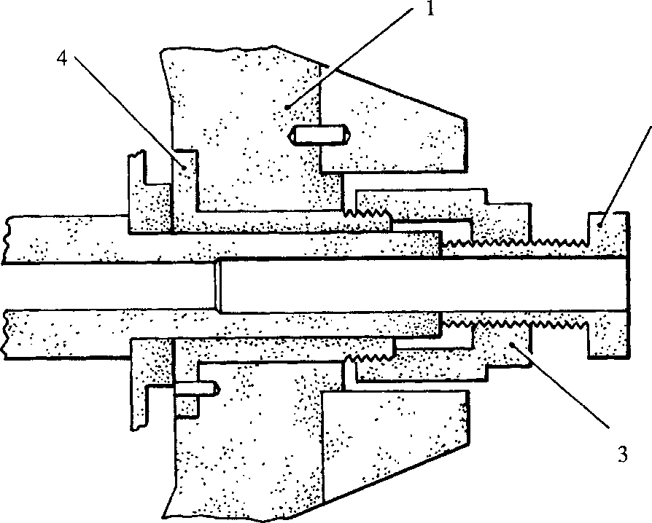SPD00373

Key To Numbers

1. Impeller/inducer assembly 3. Body
2. Jackscrew 4. Impeller insert

Fig M.4 Withdrawal, impeller/inducer assembly

1. Position the turbine inlet casing with the nozzle ring facing downwards and place a board below the casing onto which the ring may drop without damage.
2. Apply a heating torch flame to the inlet casing outer wall adjacent to the nozzle ring blade location and rotate the casing slowly to provide even heating.
3. The nozzle ring should release and drop onto the board within 2 to 4 minutes of torch application. Occasional tapping of the casing wall with a wooden block and hammer may be required.

Rotor

1. Holding rotor centre stud (24) against rotation, flats are machined on the end of the stud, remove elastic stop nut (22) and its plain washer. Remove nose piece (23).
2. Screw knocker tool (117)(Fig M.6) to stud (24). Supporting the turbine disc by hand, carefully tap the hexagon face of the tool to force turbine disc and stud from the rotor shaft. Care must be taken to prevent impact damage to the turbine end oil seal. When the fitting portion of the disc has cleared the shaft, unscrew and remove tool (117) and remove disc complete with stud.
3. The impeller/inducer assembly is an interference fit on the shaft and should be removed as follows:
4. Fully unscrew jackscrew (2)(Fig M.4) of the impeller puller.
5. Screw body (3) of the puller on to the threaded portion of the impeller insert and tighten firmly.
6. Screw in the jackscrew into contact with the end of the shaft and continue tightening to draw the impeller/inducer assembly off the shaft. Remove drive key (21).
7. Remove snap ring (38) and withdraw turbine end oil seal (37).
8. Release countersunk head screws (25) and remove impeller end oil seal (14) and thrust collar (15).

Bearing Removal

note Bearings should NOT BE WITHDRAWN unless renewal is

necessary.

1. Place shaft sleeve (109)(Fig M.6), over the reduced diameter of the shaft at the impeller end to prevent damage to the bearing bores and withdraw the shaft towards the turbine end.
2. Pass centre screw (4)(Fig M.5) of the bearing puller through the bore of the compressor end bearing, allowing toggle (2) to pivot and drop into position behind bearing.

7.1.7 Pass bridge piece (1) over the centre screw, positioning the legs on the casing, and fit nut (3) and plain washer. Tighten the nut to withdraw the bearing. Remove the positioning dowel.

1. Repeat the operation for the turbine end bearing, but with the back of the bridge piece in contact with the casing.

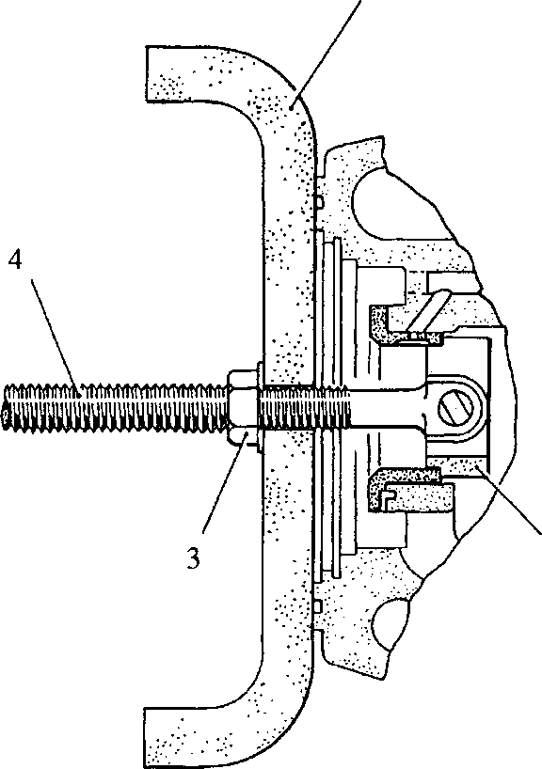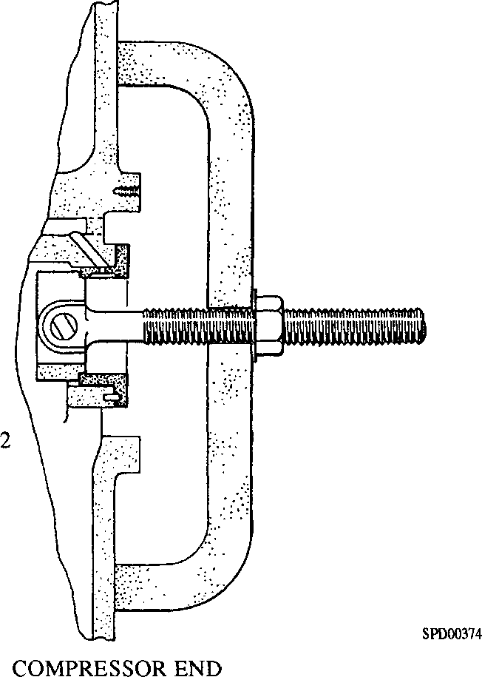

TURBINE END

Key To Numbers

1. Bridge piece
2. Toggle
3. Nut
4. Centre screw

Fig M.5 Bearing removal

CHAPTER 8

CLEANING AND INSPECTION

Cleaning

1. All components should be cleaned in a chlorinated hydro-carbon degreasing plant or washed in kerosene. If the latter method of cleaning is employed, care must be taken to thoroughly dry all components to ensure against flammability.
2. Great care must be taken when cleaning and handling the rotor components as slight damage to the turbine disc or impeller assemblies will affect the balance of the rotor unit. Never use a caustic solution, wire brush or scraper on these components.
3. Thoroughly de-carbonise the exhaust gas passages.
4. Check that all oilways and air passages are clear and free of deposits. Brush through where possible. After brushing, flush through and dry using compressed air.
5. Coolant spaces may be de-scaled, if necessary, using a proprietary solution recommended for de-scaling engine water jackets. After de-scaling, drain off the solution, neutralise and flush the passages with hot fresh water.
6. Remove all traces of jointing material and flexible gasket 16113 and inspect all mating faces for burrs and indentations which may impair sealing efficiency.

Inspection

1. The bearings and their mating surfaces on the shaft are the only normal wearing parts of the turbocharger. The bearings can be inspected for both size and surface finish without removal. Bearings should be renewed if worn beyond the figures quoted in Chapter 9, or if the surface shows pitting, corrosion or local wear.

NOTE Care must be taken when measuring bearing bore sizes. The bearings are of a three lobe design and unless measurements are taken on the three lobes, a serviceable bearing may appear to require renewal.

1. If the mating shaft journal surfaces are scored, the finish should be improved by polishing with crocus cloth. Slight scoring of the thrust face is not objectionable, if tolerances are within limits.
2. Normally the oil seals are subject to very little wear, but the bore should be checked to ensure that wear has not occurred. The oil seal limits are quoted in the table.
3. Inspect the turbine disc for mechanical condition, blade tightness, etc, and the impeller/inducer assembly for evidence of rubbing or mechanical wear. With the exception of the elastic stop nut, the replacement of individual rotor components may only be carried out by the manufacturer due to the requirement of re-balancing the assembly. If any components require replacement a new rotor assembly must be fitted.
4. The turbine nozzle ring should be examined for distortion, or warping of the blades and checked for cracks, using a dye penetrant or similar type product. This part is always subject to cyclic elevated temperatures and should be checked carefully. DO NOT REMOVE the nozzle ring from the inlet casing unless it is to be renewed.

LIMITED RIGHTS LEGEND

**rs r\** USE, DUPLICATION OR DISCLOSURE OF THIS INFORMATION WHICH IS THE PROPERTY

ZU OF GEC ALSTHOM DIESELS LIMITED BY THE U.S. GOVERNMENT OR BOLLINGER IS

SUBJECT TO THE RESTRICTIONS SET FORTH IN DOD FAR SUPP 252.227-7013 (a) 15.

CHAPTER 9

CLEARANCES

(All dimensions are in inches)

|  |  |
| --- | --- |
| Rotor end float | 0.0070 to 0.0180 |
| Journal Bearings: |  |
| Shaft diameter | 1.8690 to 1.8695 |
| Bearing bore | 1.8740 to 1.8745 |
| Oil Seals, Turbine and Blower End: |  |
| Seal bore | 2.694 to 2.695 |
| Shaft diameter | 2.686 to 2.687 |
| Radial clearance between turbine |  |
| blade OD and inlet casing | 0.010 to 0.035 |
| Radial clearance between nozzle ring |  |
| blade OD and inlet casing, cold | 0.0075 to -0.0075 |
| Clearance, impeller blade tip to |  |
| blower inlet casing (MUD CHECK) | 0.0560 to 0.0810 |
| Clearance, inducer to blower inlet casing | 0.0250 to 0.0560 |

Worn parts should be replaced or adjustments made to assure that operating clearances will not exceed above values.

NOTE When ordering these parts, the turbocharger model and SERIAL numbers must be furnished.

CHAPTER 10

TURBOCHARGER ASSEMBLY

NOTES 1 The fitting procedure for the turbocharger bearings requires that,

before they are fitted to the intermediate casing, the bearings are frozen to -30°C. If, after freezing, difficulty in fitting the bearings is experienced, an alcohol/dry ice bath method of freezing must be employed. In this instance, the cautions detailed below must be observed.

2 All joints and 'O' rings must be fitted dry.

Health and Safety

1. Due to the very low temperatures involved (-78°C) with the use of an alcohol/dry ice bath, insulating gloves and a face visor, for face and eye protection from liquid splashes must be worn at all times when handling dry ice or frozen components. NO DIRECT PHYSICAL CONTACT SHOULD BE MADE.
2. For freezing components, a special insulated bath with a close fitting lid should be used and components lowered in and removed with a suitable hooked tool. Due to their brittleness, handling of frozen components should be kept to a minimum.
3. Dry ice should be kept in a sealed and insulated container and alcohol in a sealed container; alcohol is also highly flammable and therefore the alcohol/dry ice bath should only be used in a well ventilated area, away from any naked flame.

Bearing Installation

1. When fitting new bearings the following points must be observed
2. The turbine end bearing (4) has a grooved thrust face
3. The drilled hole in the back of the bearing flange must engage with the locating pin fitted to the intermediate casing
4. The bearings are an interference fit and must be frozen before attempting to insert into the intermediate casing. Pre-chilling in a standard refrigerator is also recommended.
5. Check that the bearing locating pins are securely fitted in the intermediate casing.
6. Place the compressor and turbine end bearings into a commercial freezer at -30°C and leave for 24 hours.
7. Remove turbine end bearing (4) from the freezer using insulating gloves and insert into casing, ensuring correct engagement with its locating pin and that the back of the bearing flange is in full contact with the casing. If the bearing proves difficult to install, do not attempt to drive the bearing into the casing, but re-freeze both bearings in an alcohol/dry ice bath as follows:-

10.7.1 Using a 1 cu ft capacity insulated bath with a close fitting lid, place an 8 in cube of dry ice into the bath, add xh pt of alcohol and immediately place the bearings into the bath, ensuring that they are not touching each other. Close the lid and leave the bearings for 1 hour.

1. After one hours freezing remove turbine end bearing (4) and insert it into the casing ensuring correct location with its locating pin and that the back of the bearing flange is in full contact with the casing.
2. Allow the bearing to warm sufficiently to expand and secure itself into position in the casing.
3. Check the clearance between the bearing flange and the casing. This should not exceed 0.001 in. If the clearance is greater than 0.001 in. the bearing should be tapped into position using a wooden block and hammer and the clearance re-checked.
4. Repeat for impeller end bearing (11).
5. It is extremely important that the bearings are installed in proper alignment. To check, lightly spread engineers marking blue on the thrust face of the shaft, insert into the bearing bores and blue check the contact with the bearing thrust face. Contact should be uniform. The shaft sleeve should be fitted to prevent damage to the bearing bores during insertion.

Nozzle Ring Installation

1. Place nozzle ring (39) in an alcohol/dry ice bath (see Bearing Installation above) for a period of 1 hour prior to assembly.
2. Submerge the entire turbine inlet casing (1) in a hot water bath, set at 190°F, for a minimum period of 20 minutes prior to assembly.
3. Remove the turbine inlet casing from its bath, allow the water to evaporate off, remove the nozzle ring from its bath and using suitable guide bars to align the nozzle ring bolt holes, lower the nozzle ring into position in the turbine inlet casing.
4. Allow the nozzle ring to warm up to room temperature. Apply anti-seize compound, i.e. Poly Butyl Cuprysil (PBC) to the bolt threads, fit bolts (33) with plain washers, spacers (34) and nuts (35) and tighten to a torque loading of 45 lbf.ft.

Rotating Assembly

1. Fit shaft sleeve, (109)(Fig M.6) to compressor end of shaft (5), lightly oil the shaft and insert into the bearings. Remove the shaft sleeve.
2. Coat the mating surface of turbine end oil seal (37) where it contacts the intermediate casing with flexible gasket 16113, position in the casing and fit snap ring (38), bevelled side out.
3. Slide thrust collar (15) on to the shaft and into contact with bearing (11).
4. Coat the mating surface of impeller end oil seal (14) where it contacts the intermediate casing with flexible gasket 16113, position in casing and secure with countersunk head screws (25). Tighten to a torque loading of 30 to 40 lbf.ft. and lock by peening the oil seal material into the screw slots.
5. Lightly smear the turbine disc hub with PBC anti-seize compound, insert the assembly into the shaft, align the dowel holes and tap the assembly into position. The turbine disc will only mount in one position as controlled by the relative positions of pins (36) in the shaft and the matching holes in the disc.
6. Heat impeller/inducer assembly (20) to a temperature of between 190°F and 212°F by immersing in a bath of hot oil. DO NOT use a torch because of non-uniform heating.
7. Coat the impeller portion of the shaft with PBC and slide the impeller inducer assembly on to the shaft as far possible, aligning the keyways in the shaft and impeller bore. Insert key (21) and fit nose piece (23) aligning the punch marks on the impeller and nose piece to maintain rotor balance.
8. Fit plain washer and elastic nut (22) and holding the centre stud by means of the flats, tighten the nut to a torque loading of 60 lbf.ft.
9. The rotor assembly should turn freely and the end float checked with a dial indicator; end float should be within the limits quoted in Chapter 9.
10. After checking end float, oil the bearings through the lubricating oil inlet at the top of the intermediate casing. Turn the rotor by hand to ensure that oil is distributed over the bearing surfaces.

Casings

1. Insert turbine inlet casing (1) into turbine casing (2), apply a smear of PBC to the threads of capscrews (32), fit the capscrews together with spring washers and tighten to a torque loading of 120 to 130 lbf.ft.
2. Screw intermediate casing guide pins (3)(Fig M.3), into the turbine casing and fit gasket (29).
3. With the aid of suitable lifting gear, fit the intermediate casing assembly and secure with capscrews (6) and spring washers. Remove guide pins and fit the remaining two capscrews (6) and spring washers. Tighten the capscrews to a torque loading of 75 to 80 lbf.ft., PBC should be applied to the capscrew threads.
4. Apply a light coat of 'Titeseal' to the mating faces of intermediate casing (10) and blower casing (13). Fit blower casing. Using PBC on the threads, fit nuts (7) and spring washers, evenly tightening to a torque loading of 30 to 40 lb ft.
5. Fit diffuser ring (27) to blower inlet casing (16) and secure with countersunk head screws (12). Tighten securely and lock by peening diffuser material into the screw slots.
6. Apply flexible gasket 16113 to the mating face of the blower inlet casing (16), lift into position taking care not to damage the impeller/inducer assembly and secure with setscrews (26) and spring washers. Tighten to a torque loading of 30 to 40 lbf.ft.

CHAPTER 1

SPECIAL TOOLS

In addition to standard workshop tools, the following special tools are also required for turbocharger assembly and dismantling procedures.

NOTE These tools are only shown in the Illustrated Parts List if they have been ordered as part of the contract.

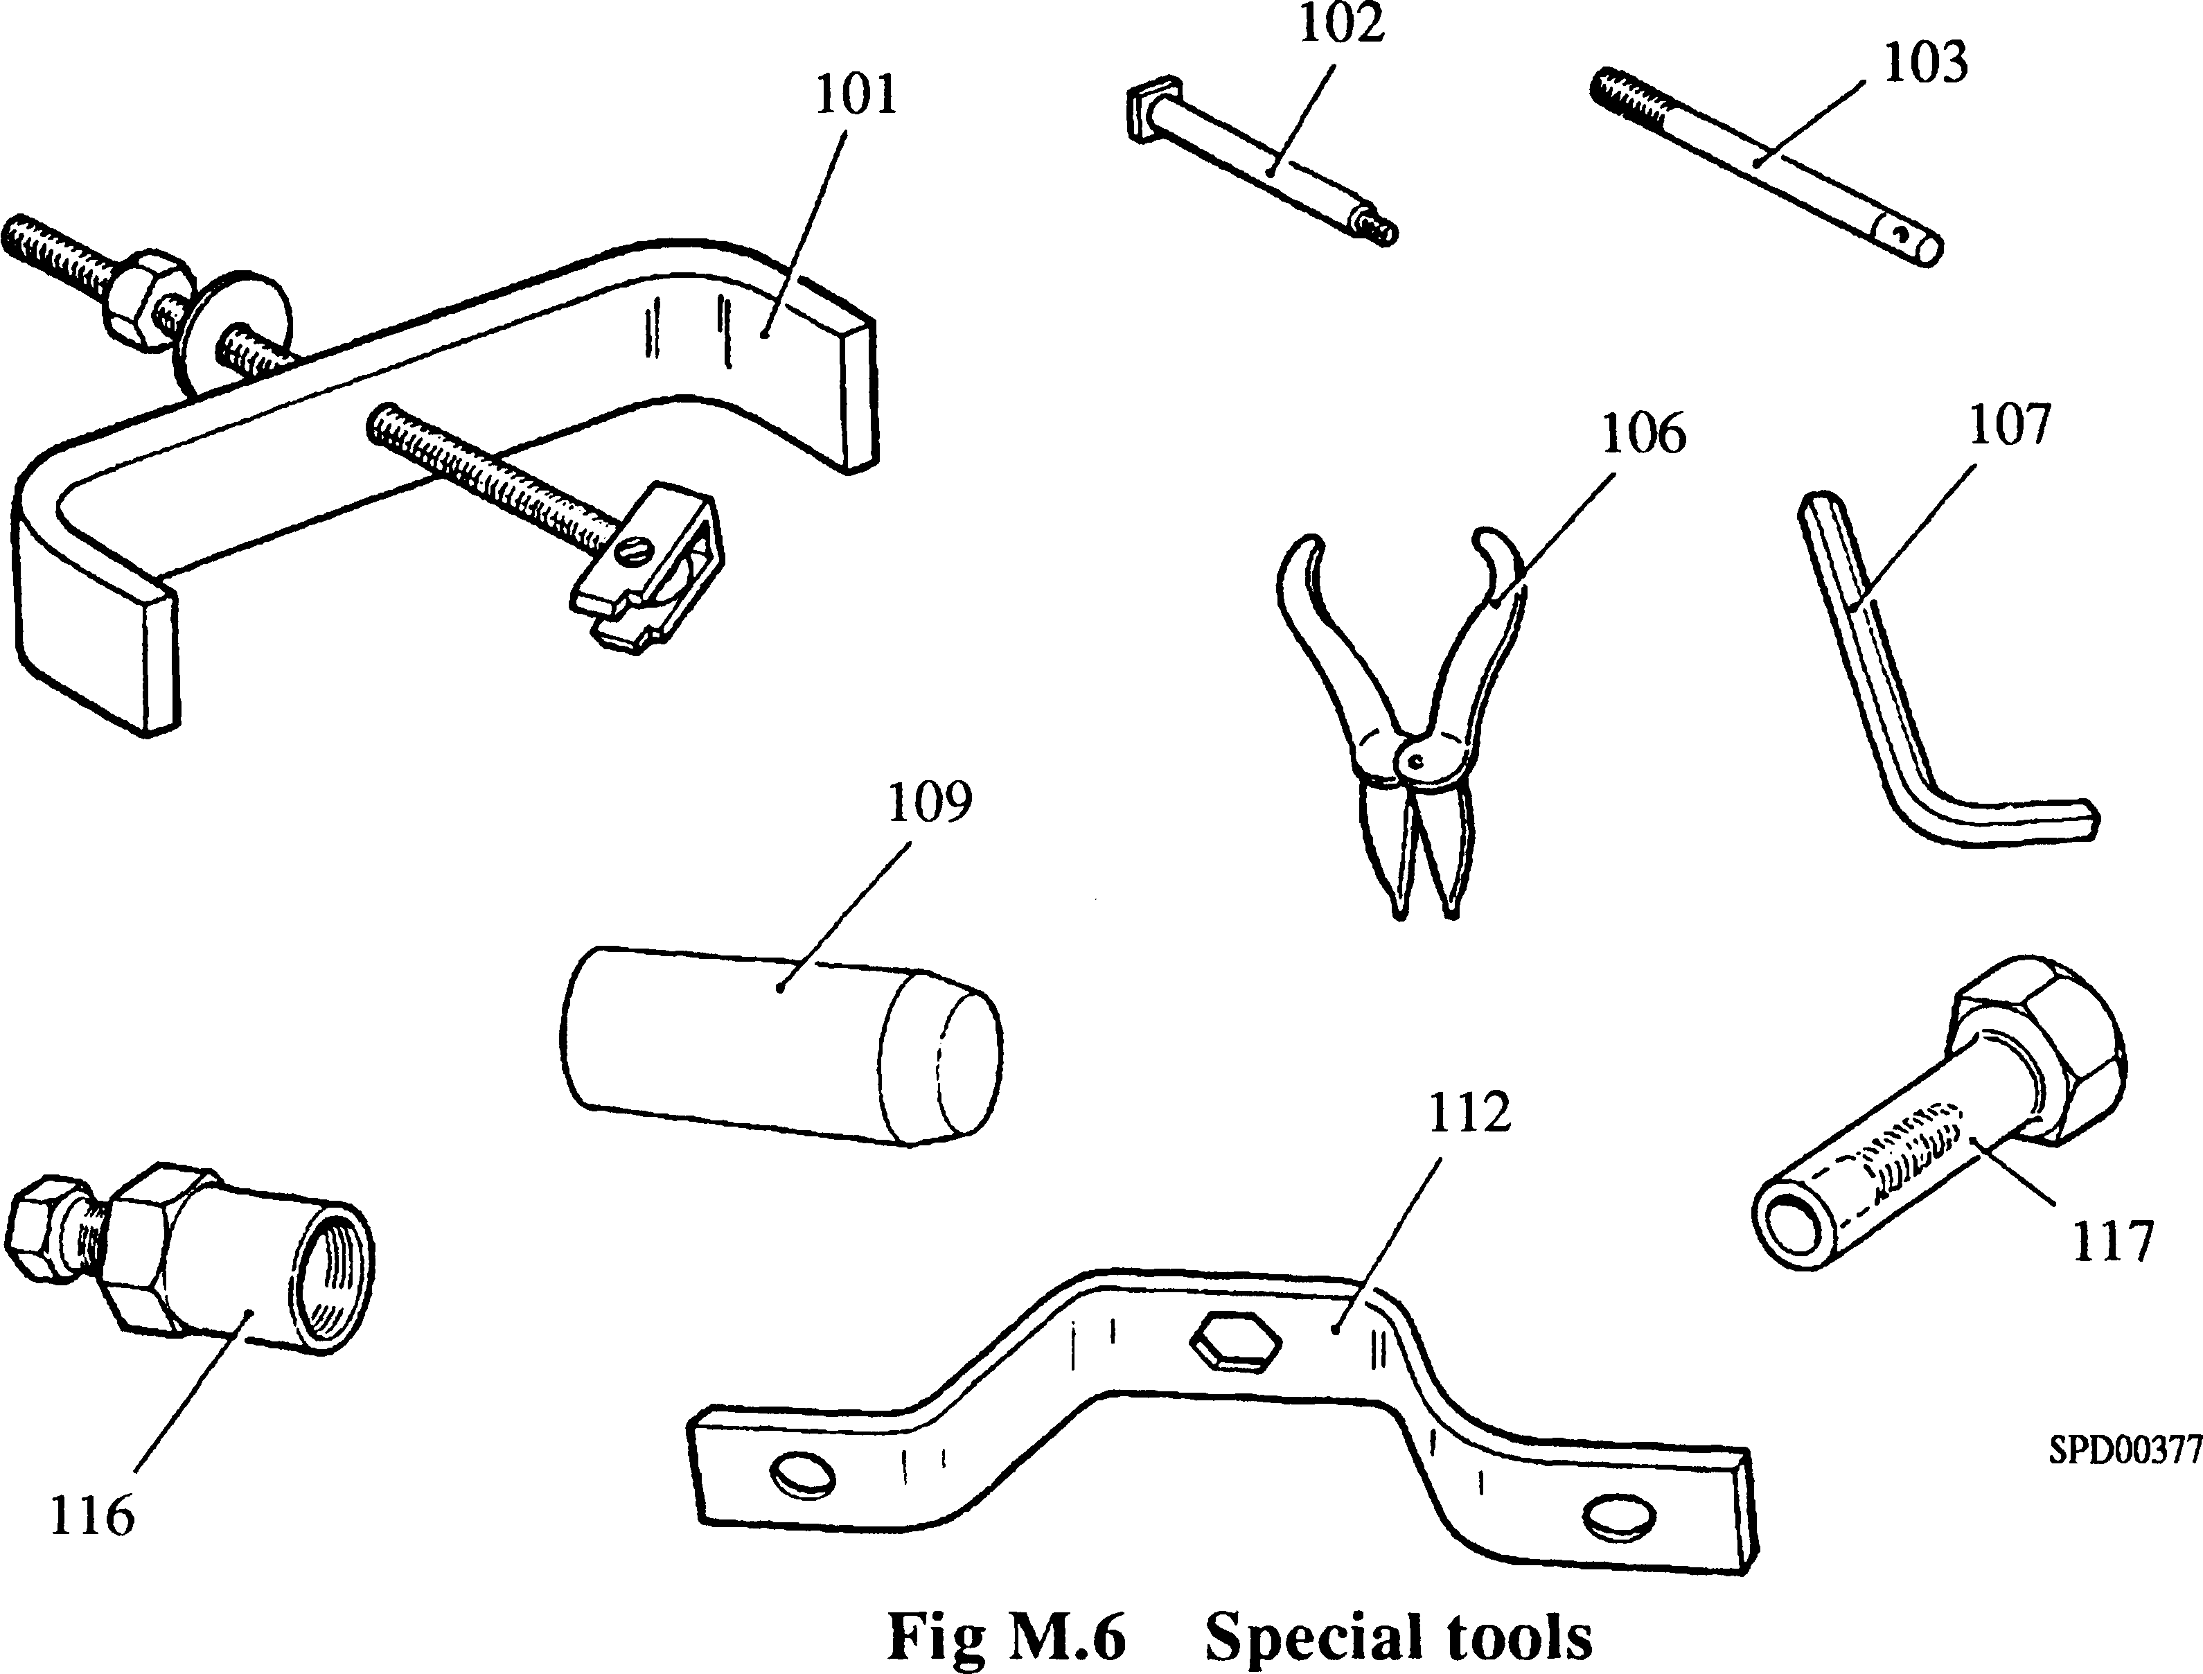

|  |  |  |
| --- | --- | --- |
| ITEM | NAME | USE |
| 101 | Bearing Puller | Removal of bearings from intermediate assembly casing. |
| 102 | Jack Screws | Breaking joint between intermediate and turbine casings. |
| 103 | Guide Pins | To guide intermediate casing assembly to avoid damage to turbine blades. |
| 106 | Snap Ring | Fitting and removal of snap ring pliers retaining turbine end oil seal. |
| 107 | Hexagon Key | Removal and fitting of capscrews securing intermediate casing to turbine casing. |
| 109 | Shaft Sleeve | To prevent damage to bearing bores during removal and fitting of rotor shaft. |
| 112 | Rotor Blocker | To prevent rotation of rotating assembly during turbocharger emergency operation. |
| 116 | Impeller Puller | To draw impeller/inducer assembly off assembly rotor shaft. |
| 117 | Knocker | Removal of turbine disc from rotor shaft. |

Key To Numbers

1. Turbine inlet casing
2. Turbine casing
3. Turbine disc
4. Turbine end bearing
5. Shaft
6. Capscrew
7. Nut
8. Lifting plate
9. Stud
10. Intermediate casing
11. Impeller end bearing
12. Countersunk head screw
13. Blower casing
14. Impeller end oil seal
15. Thrust collar
16. Blower inlet casing
17. Impeller
18. Inducer
19. Impeller insert
20. Impeller/inducer assembly
21. Key
22. Elastic stop nut
23. Nose piece
24. Rotor stud
25. Countersunk head screw
26. Setscrew
27. Diffuser
28. 'Titeseal' sealant
29. Gasket
30. Bearing locating pin
31. Bearing locating pin
32. Capscrew
33. Bolt
34. Spacer
35. Locknut
36. Turbine disc locating pin
37. Turbine end oil seal
38. Snap ring
39. Nozzle ring
40. Oil supply drilling
41. Oil transfer tube

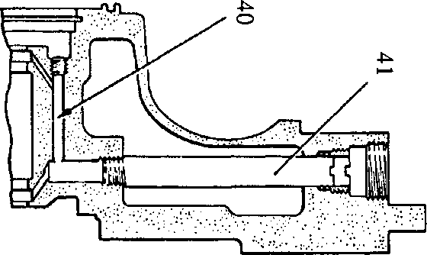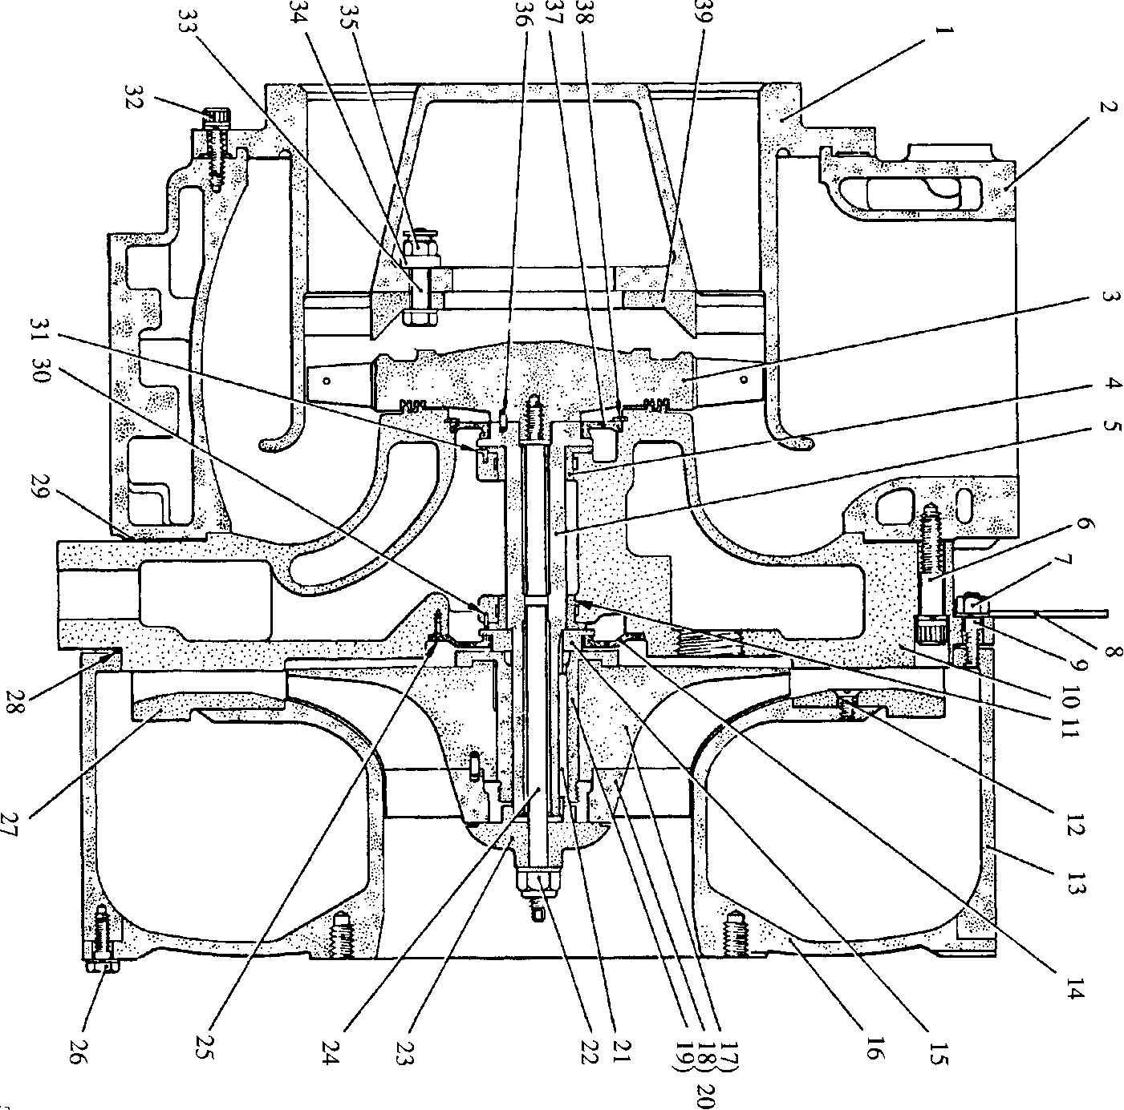

**SPD00371**

Fig M.7 Section through turbocharger

1. Lifting sling

2. Lifting shackle